Name: ___________________________
Block: ___________________________
Date: ____________________________

Getting Started: Wonder by RJ Palacio
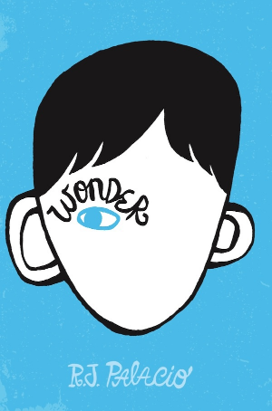
This week, we will begin reading our new book, Wonder, by RJ Palacio. Before we read, study the front cover here and answer the questions below:
1. What are two things you notice about the image on the front cover of the book?
a. ___________________________________________________
_____________________________________________________
b. ___________________________________________________
_____________________________________________________
2. What is one question you have about this book based on the artwork on the cover?
________________________________________________________________________________________________________________________________

Inside Cover….
Read the summary below.
August (Auggie) Pullman was born with a facial difference that prevented him from going to mainstream school---until now. He’s about to enter 5th grade at Beecher Prep, and if you’ve ever been the new kid, then you know how hard that can be. The thing is Auggie’s just an ordinary kid, with an extraordinary face. But can he convince his new classmates that he’s just like them, despite appearances?
1. Have you ever been the new kid at school? If so, describe what that experience was like for you. If you haven’t, try to imagine what the experience may have been like.
__________________________________________________________________________________________________
__________________________________________________________________________________________________
__________________________________________________________________________________________________
2. What do you think Auggie is going to have to do in order to convince his classmates that he’s just like them? Do you think he will be able to do it? Why or why not?
__________________________________________________________________________________________________
__________________________________________________________________________________________________
Other Discussion Questions
1. What do you think of when you hear the word “wonder?”
__________________________________________________________________________________________________
__________________________________________________________________________________________________
2. In the box below, make a list of as many things as you can that bring “wonder” to mind. As we start to read, keep track of all of the situations in which the word “wonder” is used.

Background Information: Treacher Collins Syndrome
Auggie’s condition is called Treacher Collins Syndrome. Basically, this condition affects the development of bones & other facial tissues. The severity of the abnormalities varies and can go far beyond physical appearance.
1. What do you think is the usual reaction of people when they see someone with a disorder such as this?
__________________________________________________________________________________________________
__________________________________________________________________________________________________
2. What has been your reaction when you see someone disfigured or disabled? Why do you think you react this way? Is this the reaction you would like to have?
__________________________________________________________________________________________________
__________________________________________________________________________________________________

