Name: ___________________________
Block: ___________________________
Date: ____________________________
{Wonder}: Context Clues Lesson

Goal:
I can…use context clues to find the meaning of a word or phrase.

{Introductory Passage}

Read this text…
“So sending him off to middle school like a lamb to the slaughter…,” Dad answered angrily.

Teammate talk:
- What do you think the word slaughter means?

____________________________________________________________________________________________________________________________________________________________________________________
- What information in the sentence helped you come up with this definition?

____________________________________________________________________________________________________________________________________________________________________________________

What are context clues?
- Hints the author gives you to help you figure out the _______________________ of ________________words.

How do I use context clues?
When you come across an unknown word... Ask yourself 4 questions

- _____________________: Is a similar word mentioned?
- _____________________: Is an opposite word mentioned?
- _____________________: Is there an explanation within the sentence?
- _____________________: Is there an example of the word in the sentences?

Why is this important?
- Context clues are the ______________ to becoming a ________________________________-- no story, text, or article is too hard if you can unlock _______________________________
_________________________ using the tools you have.

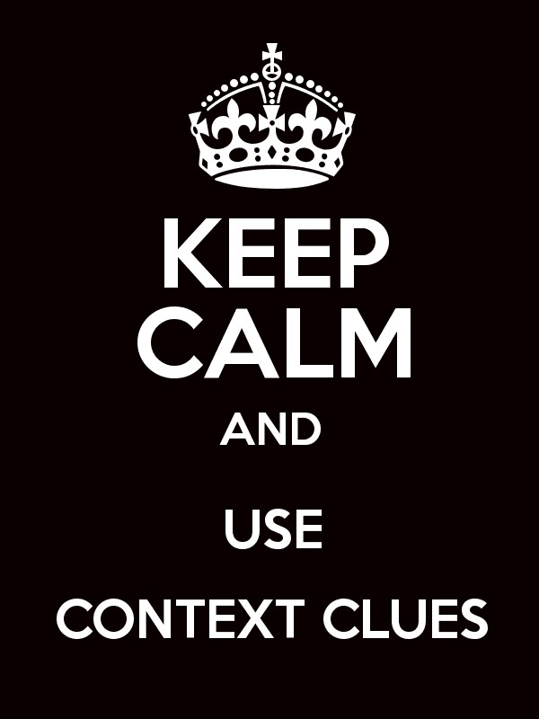
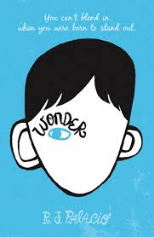

Flocabulary: Word Detectives
http://www.flocabulary.com/context-clues/
Oh, look. A word I don’t know. Well, I’m not going anywhere. I’ll be looking for clues in the context.  When I find a new word that’s written in a sentence, I look around to see if a similar one is mentioned. That’s a _______________ — the first clue I use, like:  The actress read through a book and perused  A newspaper and then she took a snooze.  Peruse? That’s new, so I search for a clue,  I see she was reading. Could it be true?  Peruse must be a synonym for “read through.”  But if I can’t find the answer, then Maybe there’s an opposite word, or an ___________________________ like:  Langston was jubilant when he got the news,  Before he found out, he was depressed with the blues.  Jubilant and depressed must be antonyms,  Depressed means sad, jubilant must mean happy then.  Two new words: peruse, jubilant,  With synonyms and antonyms, you don’t have to Google it.  On a top-secret mission, check the method, Treat words I don’t know like a word detective.  Search within the sentence, look for synonyms,  Antonyms, explanations, examples. | Detectives, when reading through phrases,  You might find the third clue - ____________________  Let’s take a look and try to crack this case then,  The mansion was dilapidated.  The windows were broken, the paint was faded,  I’m pretty sure a pack of rats had invaded.  Those lines explain the word that I didn’t know,  Dilapidated means falling down and old,  Clue four — I look for ____________________ of the word that might illustrate how to define the term.  Eating sweets was against Capone’s wishes,  Just fruits and vegetables which are nutritious.  I know fruits and vegetables are healthy dishes,  These examples lead me to the meaning of nutritious.  All these examples and explanations,  Are clues to crack the case like Perry Mason.  On a top-secret mission, check the method,  Treat words I don’t know like a word detective.  Search within the sentence, look for synonyms,  Antonyms, explanations, examples.

Directions: Use the context clues from the following excerpts from the novel Wonder to determine the meaning of the underlined words.

{TEAM Practice}

Sentence: “But you’re right, Auggie, we should’ve told you when we found out last month that you got in,” said Dad. “In hindsight,” sighed Mom, “yes, I guess.”
Context Clues | Unknown Word | Reminds you of… | Clues | My definition
 | 1. hindsight

 | Unknown Word | Reminds you of… | Clues | My definition
 | 2. sarcastically
Sentence: “I don’t think he’s going to want to be in the school play, Charlotte,” said Julian sarcastically.

Sentence: “Only dorks take leadership,” Julian interrupted.

“Julian, you’re being so obnoxious!” said Charlotte, which made Julian laugh.
Context Clues | Unknown Word | Reminds you of… | Clues | My definition
 | 3. obnoxious

{Teammate Practice}

Sentence: “It’ll be a bit of a schlep, though. The A train down to Eighty-Sixth, then the crosstown bus all the way to the East Side. Takes an hour that way but it’s just a fifteen minute drive.”

Context Clues | Unknown Word | Reminds you of… | Clues | My definition
 | 4. schlep

Sentence: I had surgery to fix my cleft palate when I was a baby, and then a second cleft surgery when I was four, but I still have a hole in the roof of my mouth. And even though I had jaw alignment surgery a few years ago, I have to chew food in the front of my mouth.
Context Clues | Unknown Word | Reminds you of… | Clues | My definition
 | 5. alignment

Name: ___________________________
Block: ___________________________
Date: ____________________________
Independent Practice: Wonder Context Clues Lesson

Directions: Use the context clues from the following excerpts from the novel Wonder to determine the meaning of the underlined words.

Sentence: “That’s not true,” she said. “I can’t believe you would just cut it off like that,” she said snottily, and then practically slammed my bedroom door as she left the room.

Context Clues | Unknown Word | Reminds you of… | Clues | My definition
 | 1. snottily

Sentence: “So, can I ask you something? Are you mad at Mom or something? You’ve been kind of huffy with her all night long. You know, Auggie, I’m as much to blame for sending you to school as she is.”
Context Clues | Unknown Word | Reminds you of… | Clues | My definition
 | 2. huffy

Sentence: The rest of September was hard. I wasn’t used to getting up so early in the morning. I wasn’t used to this whole notion of homework.

Context Clues | Unknown Word | Reminds you of… | Clues | My definition
 | 3. notion

Sentence: They would take the longest way around me to avoid bumping into me in any way, like I had some germ they could catch, like my face was contagious.
Context Clues | Unknown Word | Reminds you of… | Clues | My definition
 | 4. contagious

Sentence: I stopped letting anyone take pictures of me a while ago. I guess you could call it a phobia. No, actually, it’s not a phobia. It’s an “aversion,” which is a word I just learned in Mr. Browne’s class. I have an aversion to having my picture taken.

Context Clues | Unknown Word | Reminds you of… | Clues | My definition
 | 5. phobia

Context Clues | Unknown Word | Reminds you of… | Clues | My definition
 | 6. aversion

Sentence: Then yesterday in my science elective, we were doing this cool mystery-powder investigation where we had to classify a substance as an acid or a base.

Context Clues | Unknown Word | Reminds you of… | Clues | My definition
 | 7. classify

