**Literacy Test Taking Strategies**

*A champion’s mentality*

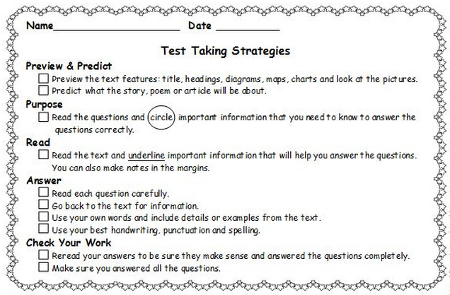

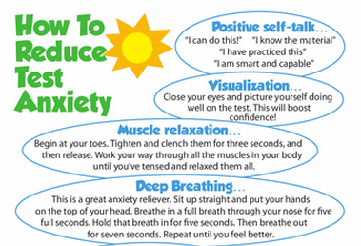

Get your game face on! ☺

**Create a question bucket!**

**-----------------------**

* At the top of the 1st page of the ELA section, draw a question bucket.
* You should spend 1.5 min. per question.
* If you don’t know an answer, skip it & come back to it at the end.
* Circle the question number & write it in the bucket.
* Continue to add question numbers you are skipping to the bucket.
* Cross them out as you answer them!