Name: ___________________________
[Summarizing Notes]
{Summarizing}
- To give a ___________________________________________ about the _________ details of a text or video.

Stop & Jot!
Why is summarizing so important?
____________________________________________________________________________________________________________________________________________________________________________________

{3 Steps to Summarizing}
- Step #1: Find the ____________ of the text or video.
- Step #2: Identify the _______________________________________ details about the topic.
- Step #3: _______________ the topic and important ______________ in a short paragraph.

{Let’s try this together!}

Directions: Watch the video clip from Finding Nemo. After we are finished watching the video, be prepared to write a brief summary and discuss it with the class.

[Finding Nemo]
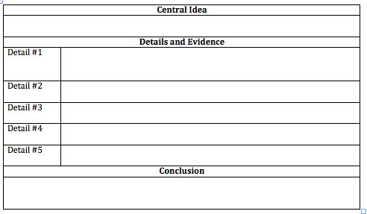
[Summary: Finding Nemo]

____________________________________________________________________________________________________________________________________________________________________________________
____________________________________________________________________________________________________________________________________________________________________________________
____________________________________________________________________________________________________________________________________________________________________________________
____________________________________________________________________________________________________________________________________________________________________________________
{Discussion of Example}

Directions: Read the following summary. Edit and revise the summary as necessary.

Summary: The State of the Union
By: Klay Thompson

Stop & Jot #2: How could Klay Thompson improve his summary?

According to Glenn Greenberg’s Time for Kids article, President Obama gave his annual State of the Union address in January. President Obama is a fantastic president and he enjoys playing basketball. First, more jobs and no more Afghanistan war. Secondly, President Obama spoke about raising taxes on the wealthy and lowering taxes on the middle-class. He talked about providing free college to American students. In conclusion, President Obama urged Republicans and Democrats to work together in Congress.
Stop & Jot #1: What did Klay Thompson do well in his summary of the Time for Kids article on President Obama’s State of the Union Address?

{Summary Frame Example}

You can use the following summary frame to help you structure your writing! However, your summary does not have to look exactly like this example!

In the article titled________________written by________________, the main idea is ___________________________. One fact or example that ___________________includes to support the main idea is __________________. Another fact or example that supports this main point is_____________. In addition, ______________________. Finally, __________________________points out _______________________________________________.

{Summary Transitions}

As a result | Finally | In conclusion
Lastly | In addition | Another
For example | For instance | Also

{Summary Reminders}

- Do I have an introductory sentence?

- Have I mentioned the name of the text, video, etc. that I am summarizing & the author at the beginning of my paragraph?

- Have I included between 3-5 important details in my summary?

- Did I indicate on my graphic organizer the paragraph & page number where I found each detail?

- Are my details really important? Do I need them to understand the message of the text, video, etc.?

- Have I used transition words? Have I used them appropriately?

- Do I have a concluding sentence?

- Does my concluding sentence wrap up my summary & provide the main idea using different words?

- Is the summary in my own words?

{Annotation Reminders}
- Did I circle the title & author of the text?
- Did I number both the paragraphs & the page number?
- Did I underline the important details/facts?
- Have I written notes in the margins? Have I written down things such as key facts, the main idea, and my opinion?
- Make sure that you did not underline too much. Make sure that you underlined just the right amount.

