Name: _________________________

[Independent Practice]: Your turn to shine!

Directions: Read the following article on the earthquake in New Zealand.
- Make sure you annotate each paragraph!
- Use your graphic organizer and follow the three steps of summarizing.

Earthquake Hits New Zealand
Strong aftershocks follow a 7.8 magnitude quake that killed two people
NOVEMBER 14, 2016
By Rebecca Katzman
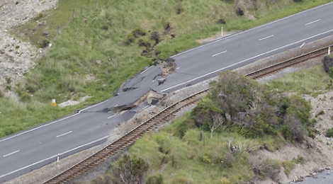
A 7.8 magnitude earthquake hit New Zealand just after midnight on Monday. The quake struck the South Island, triggering hundreds of aftershocks and a small tsunami and leaving at least two people dead. A second powerful tremor followed in the same area at around 1:45 p.m. local time, northeast of the city of Christchurch.

The earthquake and its aftershocks caused widespread damage. Roads were split apart and some large buildings showed signs of structural stress. In the coastal town of Kaikoura, a popular whale-watching destination, many residents and tourists found their water and power supplies cut off. They also had no easy way out of the area, with the town’s main road blocked by landslides. “From all directions, Kaikoura has essentially been isolated,” Darryn Webb, the Acting Commander of New Zealand’s Joint Forces, said. Authorities are working to send support to the town, according to Webb, “because it can’t support itself.”

Three cows are stranded on a small island of grass near Kaikoura, New Zealand, after a 7.8 magnitude earthquake struck the country.The military plans to send in helicopters and a navy ship to rescue about 1,000 people who are stranded there. “We’re going to get as many people and belongings out as quickly as we can,” Webb said. New Zealand’s Prime Minister, John Key, flew over Kaikoura by helicopter to view the destruction. Cars could be seen lying on their sides, and other parts of the road lay in ruins. “It’s just utter devastation,” Key said. People aren’t the only ones in the area who were left stranded. Video footage shot from a helicopter showed three cows trapped on a small island of grass, surrounded by deep valleys of collapsed earth—the remains of a small field near Kaikoura that had been ripped apart during the quake.

Capital Damage
The quake caused damage in Wellington, New Zealand’s capital, on the southern tip of the North Island. Dozens were forced onto the streets as buildings were evacuated. Australians Paul and Sandra Wardrop and their two children were on the 10th floor of the Park Hotel when they began to feel the shaking. “We felt that the building was going to collapse,” Sandra Wardrop said. “You could hear the sounds of the building shaking and see cracks appearing in the walls, in the plasterwork in the bedroom.” The family, along with dozens of others, took shelter after the quake in the city’s parliamentary complex.

The shaking was also felt in Christchurch, which is still recovering from an earthquake in 2011 that killed 185 people. Monday’s quake was more powerful than the one that struck five years ago, but it was centered in a rural area that is far less populated.

New Zealand has a population of 4.7 million. It sits on an arc of seismic faults around the Pacific Ocean called the “Ring of Fire.” Earthquakes are common in this region. The country’s Ministry of Civil Defense warned on Monday that there could be additional powerful aftershocks in the days ahead.

After touring the affected area, Key said that the cleanup effort could run into the billions of dollars. He estimated that clearing away the debris and the blocked roads could take months.
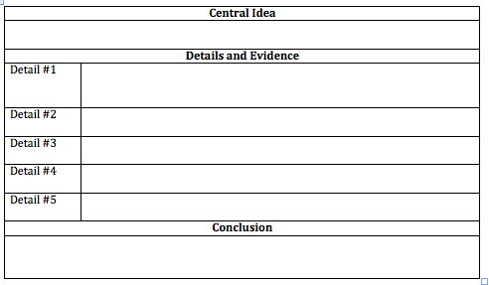

____________________________________________________________________
By: ___________________________________

______________________________________________________________________________________________
______________________________________________________________________________________________
______________________________________________________________________________________________
______________________________________________________________________________________________
______________________________________________________________________________________________
______________________________________________________________________________________________
______________________________________________________________________________________________
______________________________________________________________________________________________
______________________________________________________________________________________________
______________________________________________________________________________________________
____________________________________________________________________________________________________________________________________________________________________________________________
______________________________________________________________________________________________
______________________________________________________________________________________________
______________________________________________________________________________________________
______________________________________________________________________________________________
______________________________________________________________________________________________
______________________________________________________________________________________________
______________________________________________________________________________________________
______________________________________________________________________________________________
______________________________________________________________________________________________
____________________________________________________________________________________________________________________________________________________________________________________________
______________________________________________________________________________________________

