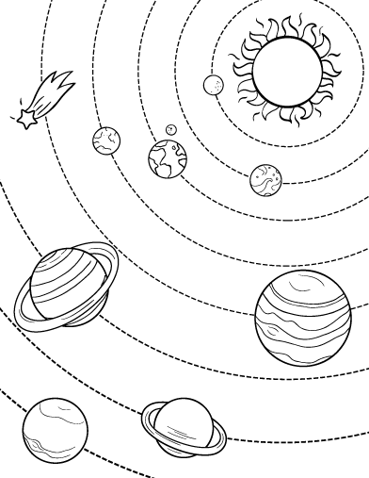

Directions: In Part Two of Wonder, Via compares her family to the galaxy. Now it’s your chance to create a galaxy that represents your life!

* Label the sun, planets, etc. based on important people and things in your life.
* Include descriptions of these people and things!
* Be creative! Add color!