Name: ________________________
Greeting:
Friendly Letter
Heading:
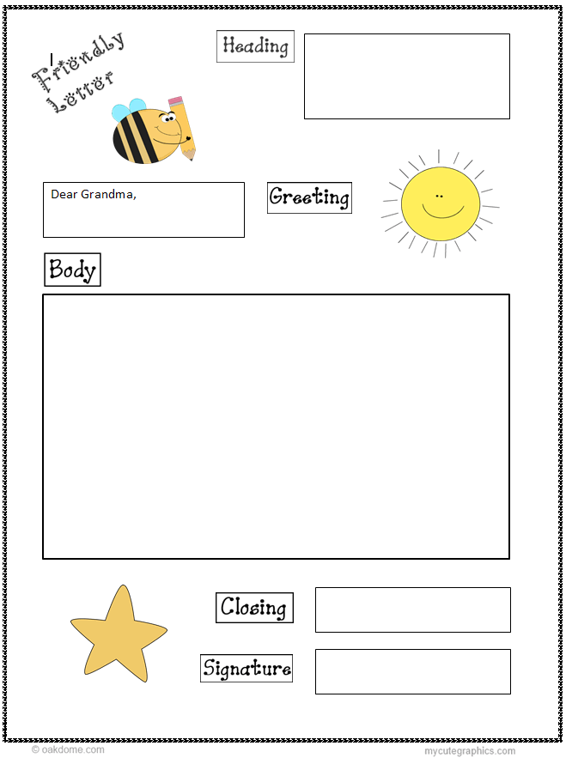
Body:
Signature:
Closing:

