Name: __________________________
Block: __________________________
Date: ___________________________
Concluding Sentences
Quick Reminder:
- The topic sentence is the ____________ sentence.
- The purpose of the topic sentence is to ___________________ the ______________ of the paragraph.

Concluding Sentences
- The concluding sentence is the _________________ sentence of the paragraph.
- The purpose of the concluding sentence is to ________________ the _____________ of the paragraph.

What’s Different ?
- The ______________.
- The ______________.

HOW DO I DO THAT?!?!
- ____________________ word.
  - ____________________________
  - ____________________________
  - ____________________________
- ____________________
- Something to ___________________ _________________.
  - A result
  - A question
  - A warning

Another Formula!
___________________ + _______________________ + ________________________

Examples:

Topic Sentence | Concluding Sentence
It is very important for Meigs students to do their homework for many reasons. | In conclusion, Meigs students should complete their homework so _____________________________________________  _____________________________________________
If people start to recycle we can save our earth. | All in all, people need to recycle because if we don’t _____________________________________________  _____________________________________________
Students can use their voices to do many incredible things in their communities. | In summary, kids can make a big difference if they speak up and _____________________________________________  _____________________________________________

TEAM Practice: Concluding Sentences
Prompt #1: Plagiarism is a form of cheating where you use someone else’s words or ideas and pass them off as your own. Write an informational paragraph that tells how plagiarism can be avoided.

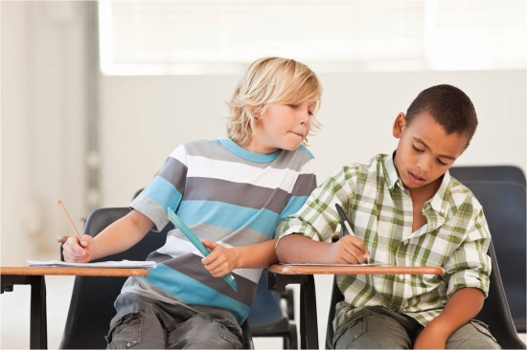
Plagiarism can be avoided. First of all, naming your source before you paraphrase is one way to avoid plagiarism. As an article from USA Today newspaper states that teachers usually teach how to list the source when you give information in your writing. This means, that plagiarism can be avoided because your teacher will give you the knowledge to do so. In addition, plagiarism can be avoided by using integrity. In fact, an article titled “Making the Right Choices in School,” says that students are the people who are responsible for their decisions in school. This means, students choose if they plagiarize and can avoid it by doing the right thing.

- What is a transition word for a concluding sentence?
__________________________________________________________________________________________
- How else can you say “plagiarism can be avoided”?
____________________________________________________________________________________________________________________________________________________________________________________
- How do you want the reader to feel after reading this?
____________________________________________________________________________________________________________________________________________________________________________________
Put it all together!
Concluding Sentence:
____________________________________________________________________________________________________________________________________________________________________________________
____________________________________________________________________________________________________________________________________________________________________________________

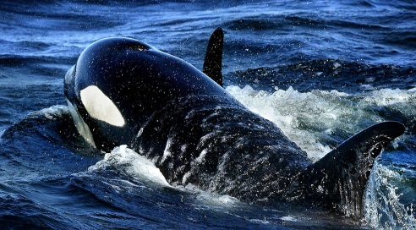
TEAMMATE Practice:
Unfortunately, killer whales are in danger for many different reasons. First of all, they are running out of food to eat. For instance, an article from The Seattle Times says, that killer whales like to eat Chinook Salmon, but recently there hasn’t been enough salmon for them to eat. Basically, killer whales are headed towards extinction because they can’t find enough fish to eat. Additionally, the killer whales are often hit by boats. For instance, the same article says that many different types of boats have hit killer whales or destroyed their breeding waters. In other words, killer whales are threatened by all of boats in the water and sometimes even hurt.
1. What is a transition word for a concluding sentence?
__________________________________________________________________________________________
2. How else can you say “killer whales are in danger”?
_________________________________________________________________________________________
3. How do you want the reader to feel after reading this?
____________________________________________________________________________________________________________________________________________________________________________________

Put it all together:
Conclusion Sentence:
____________________________________________________________________________________________________________________________________________________________________________________
____________________________________________________________________________________________________________________________________________________________________________________

SOLO Practice:
There are many reasons that it is important to save forests. First of all, we must save the forests to protect plants and animals. For example, an article from The New York Times newspaper says that they are home to many types of animals and wildlife that would not survive if we cut them down. Basically, saving the forests is important because we don’t want to kill animals. Additionally, we must save the forests now so they are not destroyed forever. In fact, the same article says that forests cannot grow back so if they disappear we will lose all the good things that come from them. This means that if we do not save the forests then they we will lose all of their resources.

1. What is a transition word for a concluding sentence?
__________________________________________________________________________________________
2. How else can you say “important to save forests”?
_________________________________________________________________________________________
3. How do you want the reader to feel after reading this?
____________________________________________________________________________________________________________________________________________________________________________________

Put it all together:
Conclusion Sentence:
____________________________________________________________________________________________________________________________________________________________________________________
____________________________________________________________________________________________________________________________________________________________________________________

