Name: __________________
“Today I will do what others won’t, so tomorrow I can do what others can’t.”
Block: ___________________
Date: ____________________

3.12 Titles & 4.3 Graphic Organizers
- I can select an appropriate title that reflects a writing topic.
- I can complete a graphic organizer.

TEAM Practice: 3.12 Titles
Question #1: Charles wrote this report for his science class. It contains mistakes. Read and annotate the report. answer the following question.

1 Amphibians are some of the most remarkable animals on Earth. They come in all colors of the rainbow. Frogs and toads are the most common amphibians. These cold-blooded creatures begin life using gills to breathe in water like fish do. As adults, however, they can breathe air and live both in water and on land. They might not make cuddly pets but amphibians are especially interesting to scientists.

2 Scientists discover many new species of amphibians every year. On a trip in 2009, scientists found a thumbnail-sized frog with a long nose. The tiny frog is just an eighth of an inch long. About a year earlier, in 2008, a different group of researchers discovered another frog with an interesting nose — the Pinocchio frog. It has a lengthy spike on its nose. Many frogs have long sticky tongues that they use to capture their prey. The Pinocchio frog points its spiked nose downward. In 2010, the same team also found a different frog species hopping along the rocks next to a stream. Generally, rocket frogs are known to be good jumpers, but they are also poisonous. In spite of this, scientists find these amphibians to be interesting and helpful to humans. This frog species was a kind of rocket frog with bright red legs.

3 Since amphibians are so important to the planet, scientists are watching them carefully. Even though scientists report that there are about 6,000 different kinds of amphibians in the world, these animals are actually in danger of becoming extinct. Pollution and climate change threaten their survival. Loss of habitat and disease are other concerns.

4 However, discoveries of new species give scientists hope for the future of amphibians. Some scientists believe that there may be as many as 10,000 different species! That is great news, but it’s still important to keep them safe. These fascinating creatures do the same for us!

5 These discoveries of new amphibian species are excellent news for humans. Amphibians help protect people. Eating insects that carry disease and destroy food crops. Tadpoles help to keep fresh water clean by eating algae. Some frogs and toads even have chemicals in their skin that can be used in medicines. Scientists consider amphibians an “indicator group.” This means that the behavior and health of frogs and toads in an area show how healthy the environment is for humans and other animals.

Which title would be best for Charles’s report?
- Amazing Amphibians
- Attractive Amphibians
- Amphibians in Danger
- Amphibians around the World

Stop! Collaborate & Listen!
Why is your answer the best choice for a title for Charles’s report? Cite evidence from the report!

TEAM Practice: 4.3 Graphic Organizers
Question #2: Read this flier. Then answer the following question!

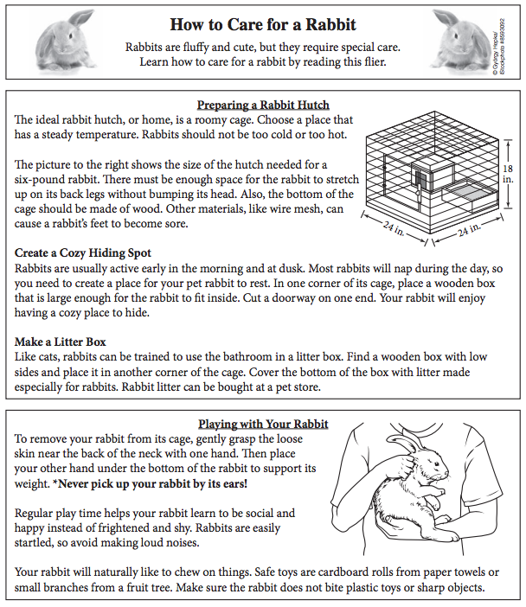

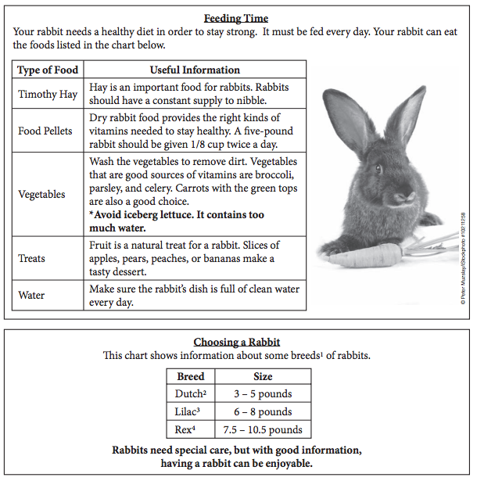
Look at the diagram based on the flier.
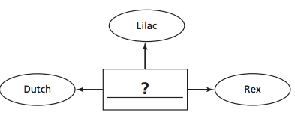

Which title belongs in the rectangle?
- Names for Pet Rabbits
- Types of Rabbits
- Famous Pet Rabbits
- Rare Rabbits

Stop! Collaborate & Listen!
Why is your answer the best choice for a title? Cite evidence from the report!

Champ: __________________
4.3 Graphic Organizers

______/ 1 = ________ %
3.12 Titles

______/ 1 = ________ %
Block: ___________________
Date: ____________________

Independent Practice: 3.12 Titles & 4.3 Graphic Organizers

“Today I will do what others won’t, so tomorrow I can do what others can’t.”

[3.12] Question #1: A student wrote the following report. It contains mistakes. Read the report and answer the following question.
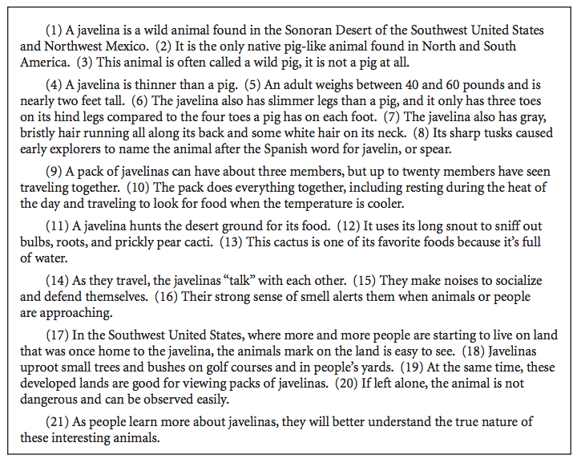
Which title would be best for this report?
- Long Snout, Thin Legs
- Javelinas: Wild But Not Pigs
- Finding a Home for the Javelina
- Wild Animals of the Sonoran Desert

[4.3] Question #2: Henrika wrote the following draft of a report. It contains mistakes. Read the
report and answer the following question.
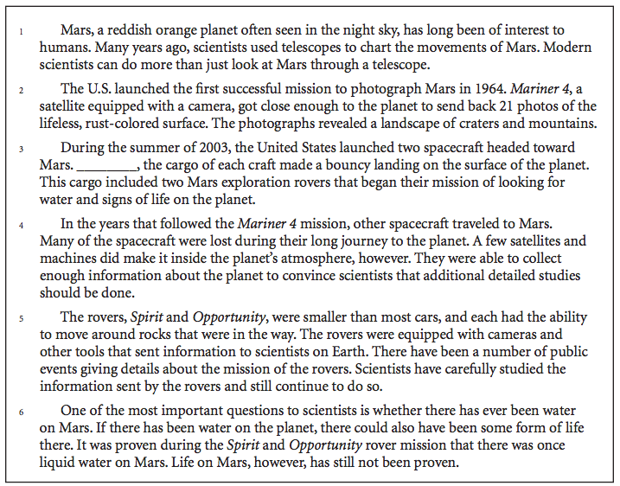
A student began the following Venn diagram after reading Henrika’s report. Use it to answer the question.
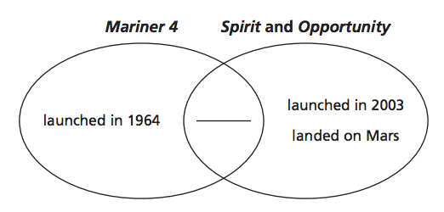
Which of these belongs on the blank line?
- used a telescope
- took photographs
- had tools
- was a satellite

Above & Beyond: On a separate sheet of paper, create a graphic organizer answering the following prompt: Which animal is more similar to you in personality: a dog or a cat?

