Name: __________________________
Block: __________________________
Date: ___________________________

Topic Sentences & Details
I can select details that support a topic sentence.
I can choose a sentence that best supports a topic sentence.
Goal:

{TEAM Practice}

Directions: Henrika wrote the following draft of a report. It contains mistakes. Read the report and answer the following question. Annotate each paragraph & question!!

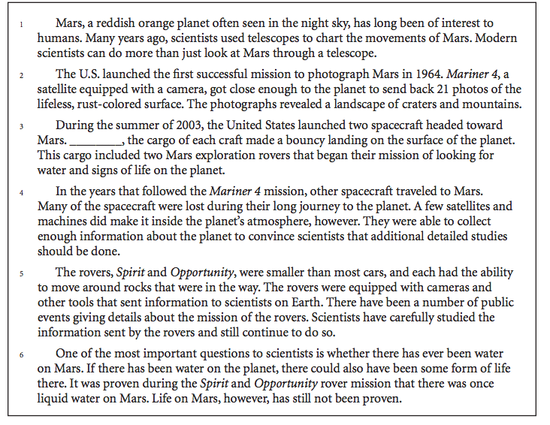

Which sentence, if added at the end of Paragraph 1, best supports the main topic of the paragraph?

- Scientists first began using telescopes in the early 1600s.
- Cameras today can take much sharper images than earlier models.
- Scientists in the United States can actually study the surface of the planet.
- Photographs of planets are known to become important historical records.

Which sentence best supports the ideas in Paragraph 3?

- The details of these missions are too numerous to describe here.
- Other planets are as interesting, but most of them are farther away.
- Satellites were unable to take pictures of the rovers themselves.
- Scientists were eager to learn more about the planet’s surface and atmosphere.

Stop & Jot: Why is it important to know how to select appropriate sentences to add to a paragraph?
________________________________________________________________________________________________________________________________________________________________________________________________________________________________________________________________________________________________________________________________________________________________________

{Teammate Practice}

Directions: Here is the first draft of Alex Morgan’s essay. It may contains some errors. Read the rough draft and answer the following questions. Annotate each paragraph & question!!

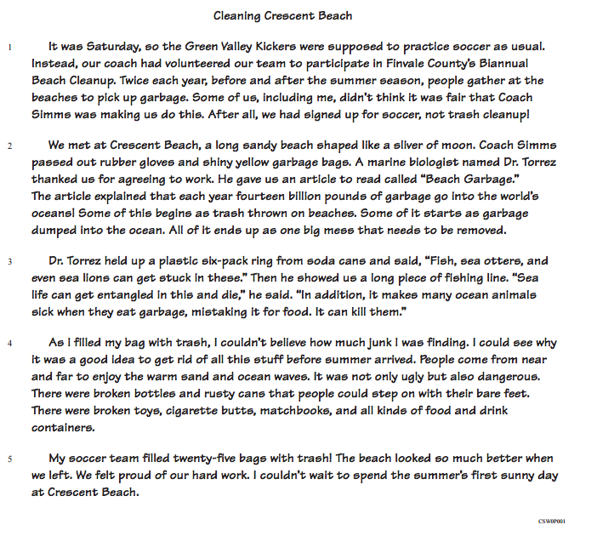

- Which sentence could Alex Morgan add at the end of paragraph 1 to help develop the situation?

- Our coach always insisted that we arrive at soccer practice on time.
- She told us, however, that being a good sport wasn’t always about playing sports.
- Last year I had played baseball, but this year I had decided to play soccer.
- The beaches in Finvale County are well-known for their fine swimming water.

- Which sentence could Alex add at the end of paragraph 5 to help summarize her essay?
- I also looked forward to the end of September when I would help to clean it up again.
- There are many other beautiful beaches in our county, too.
- Many bags of garbage were filled at Crescent beach that day.
- We usually play soccer on Saturdays, but one time we did something else.

Stop & Jot: How can you apply today’s lesson on topic sentences & details to your own writing? Be specific!
________________________________________________________________________________________________________________________________________________________________________________________________________________________________________________________________________________________________________________________________________________________________________

Name: __________________________
Mastery Score:

______/3 = ________%
Block: __________________________
Date: ___________________________

Independent Practice:
Topic Sentence & Details
Directions: Charles wrote this report for his science class. It contains mistakes. Read the report and answer the following questions. Annotate each paragraph & question!!

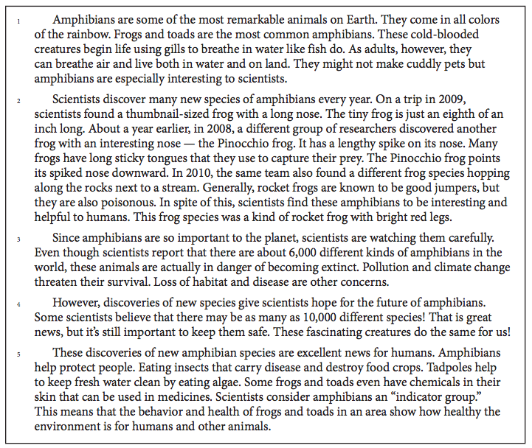

1. Which sentence, if added to the end of Paragraph 3, best supports the main topic of the paragraph?

- Amphibians live on every continent in the world except for Antarctica.
- Amphibians are an important part of many ecosystems around the world.
- South America’s rain forests are home to many different kinds of amphibians.
- These threats could cause one-third of the world’s amphibians to become extinct.

Directions: Maggie wrote a letter to her cousin. It contains mistakes. Read the letter and answer the following question. Annotate each paragraph & question!!

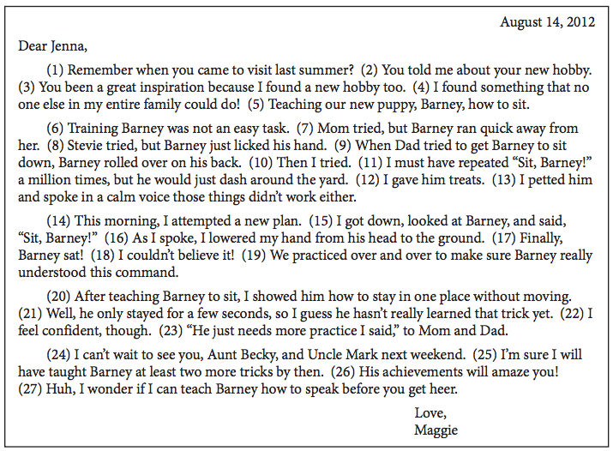

2. Which sentence could best be placed after Sentence 10 to add support to the second paragraph?

- He is the cutest puppy in the world.
- I spent many hours outside with him.
- There are many books on how to train a dog.
- I was not sure what would happen next.

Directions: Annotate each paragraph and question. Choose the best answer!

A student wrote the following report. It contains mistakes. Read the report and answer the following question.

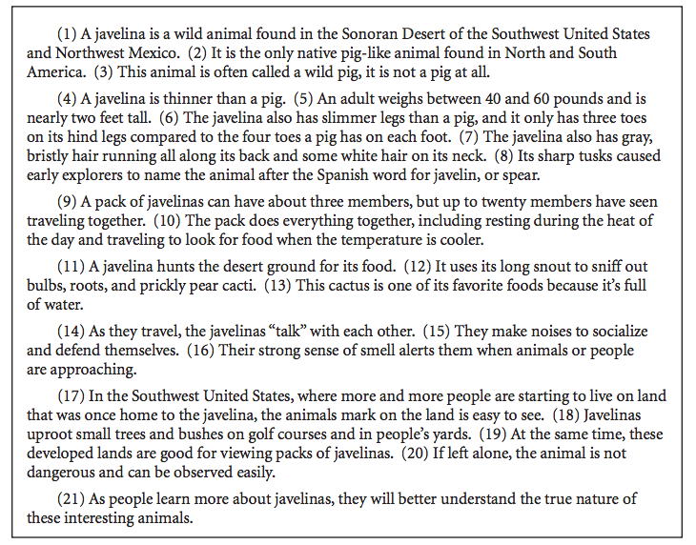
- Which sentence, if added after Sentence 13, best supports the main topic of Paragraph #4?
- The javelin also eats bugs and lizards.
- People should never try to feed a javelina.
- Traveling in a pack is not necessary for javelinas.
- Javelinas also use their ears to protect themselves

