Name: __________________________
Block: __________________________
Date: ___________________________

1.8 Sentence Combining Techniques & 1.9 Correct Run-On Sentences

- Read the following sentences. {1.8}

The dogs spend most of the time running around the yard. They also enjoy a game of fetch with a tennis ball every now and then.

What is the correct way to combine these sentences?

- The dogs spend most of the time running around the yard, they also enjoy a game of fetch with a tennis ball every now and then.

- If the dogs spend most of the time running around the yard, they also enjoy a game of fetch with a tennis ball every now and then.

- Although the dogs spend most of the time running around the yard, they also enjoy a game of fetch with a tennis ball every now and then.

- The dogs spend most of the time running around the yard, or they also enjoy a game of fetch with a tennis ball every now and then.

- Read the following sentence. {1.9}

It takes a lot of work to keep our shelter running smoothly we appreciate new volunteers.

What is the correct way to write this sentence?

- It takes a lot of work to keep our shelter running smoothly, we always appreciate new volunteers.

- It takes a lot of work to keep our shelter running smoothly; and we always appreciate new volunteers.

- It takes a lot of work to keep our shelter running smoothly, and we always appreciate new volunteers.

- It takes a lot of work to keep our shelter running smoothly, but we always appreciate new volunteers.

Above & Beyond: Explain why each of the other answer choices is incorrect! On the back of this page, create 5 sentences that need to be corrected using a conjunction, semicolon, period, or transitional phrase.

Name: __________________________
Block: __________________________
Date: ___________________________

3.6 & 3.11 Rearranging Sentences & Paragraphs in Sequential Order
I can rearrange sentences so that they are in sequential order.
I can rearrange paragraphs in sequential and chronological order.

{3.6 Rearranging Sentences}

(1) Anthony is always full of energy, but Miranda had many activities planned to keep him busy.
(2) Miranda was excited about her very first baby-sitting job.
(3) She had taken a baby-sitting class and felt confident she would be a great babysitter.
(4) Aunt Sara wanted to hire her to baby-sit her four-year-old cousin, Anthony.

What is the best order for these sentences?

- 1, 2, 3, 4
- 2, 1, 4, 3
- 2, 3, 4, 1
- 4, 2, 3, 1

(1) Early metal workers played an important role in the history of America.
(2) Interestingly, because of their skill with tools, some blacksmiths even worked as dentists.
(3) In the early 1700s, blacksmiths made items that helped other people do their own work.
(4) For example, blacksmiths made tools for farmers and repaired wagon wheels.
(5) They also made and fitted horses with special metal shoes

What is the best order for these sentences?

- 1, 2, 4, 5, 3
- 1, 3, 4, 5, 2
- 1, 5, 2, 3, 4
- correct as is

Making a Banana Split
- Enjoy this yummy dessert!
- After the banana has been sliced, set the banana halves in a serving dish.
- Place three scoops of ice cream on the banana halves.
- First, slice a banana in half from end to end.
- Top the ice cream and banana halves with chocolate syrup and whipped cream.

The steps are out of sequence. What is the best order for the steps?

- 1, 4, 5, 3, 2
- 2, 3, 4, 1, 5
- 4, 2, 3, 5, 1
- 4, 5, 2, 1, 3

Read the following sentences.
1) Someday I’d like to travel to Africa and join these volunteers.
2) They work with the native people to make things better for everyone—gorillas and humans alike.
3) This is called conservation medicine.
4) The volunteers believe that keeping animals, people, and the environment healthy go hand in hand.

Choose the correct order of these sentences.
- 1, 3, 2, 4
- 1, 2, 4, 3
- 1, 4, 3, 2
- correct as is

{3.11 Rearranging Paragraphs}

Henrika wrote the following draft of a report. It contains mistakes. Read the report and answer the following question. Annotate each paragraph & question!!

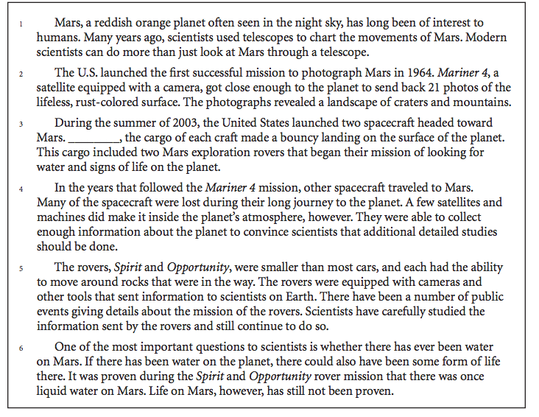

Paragraphs 2, 3, and 4 are in the wrong order. What is the correct order for these paragraphs?

- 2, 4, 3
- 4, 2, 3
- 3, 4, 2
- 4, 3, 2

Nancy wrote this report. It contains mistakes. Read the report and answer the following question. Annotate each paragraph & question!!

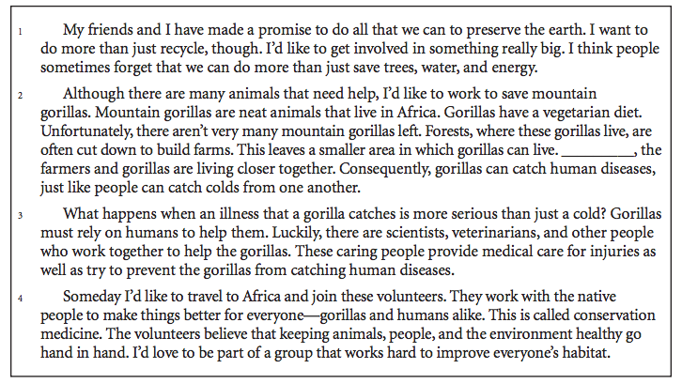

How should Paragraphs 2, 3, and 4 be arranged to present a logical order?

- 2, 4, 3
- 4, 3, 2
- 3, 2, 4
- correct as is

Directions: Charles wrote this report for his science class. It contains mistakes. Read the report and answer the following questions. Annotate each paragraph & question!!

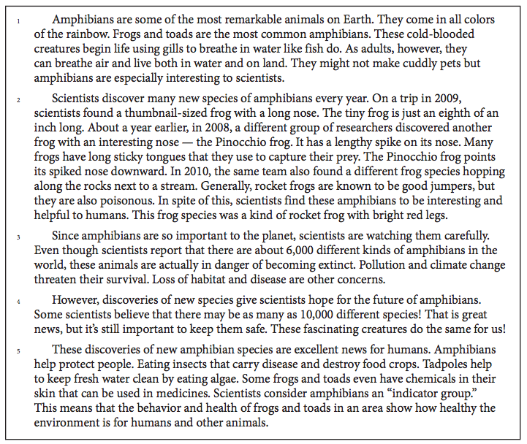

Paragraphs 3, 4, and 5 are in the wrong order. What is the correct order for these paragraphs?

- 5, 3, 4
- 4, 3, 5
- 5, 4, 3
- 4, 5, 3

