Name: _________________
Prepositions Notes
Definition: Prepositions
- A __________________ is a word that shows the connection _____________ other words in the sentence.
- Some prepositions are used to show time, ________________, and direction.
- Other prepositions, such as with and about provide ______________.

Definition: Prepositional Phrases
- A _______________________ begins with a ____________ and ends with a _________ or _____________
- The noun or pronoun is the ___________ of the preposition

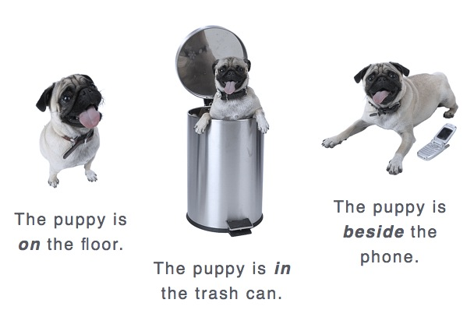
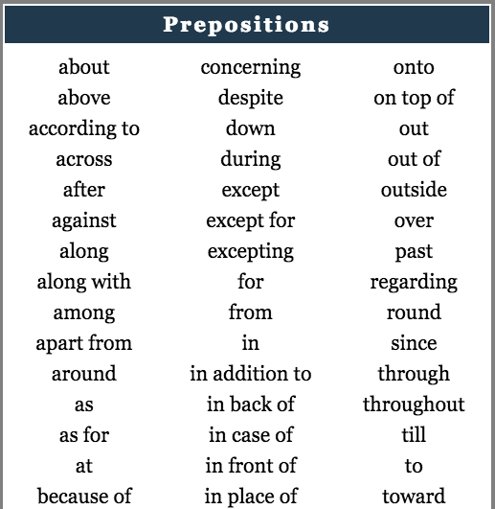
Examples:
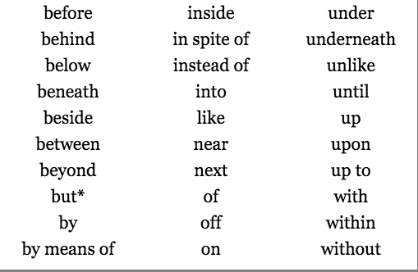

Prepositional Phrase Formula:
preposition + noun/pronoun

Directions: Put brackets around the prepositional phrase. Circle the preposition & underline the noun/pronoun (object of the preposition).
- Mr. Johnson walked his dog across the street.
- Adrian leaned against the tree.
- Put the papers by the recycling bin.
- Henry put his toys under his bed.
- There are multiple materials in the bin.
- The teachers worked throughout the day.
- The dog with the spots is mine.
- The school’s entrance faces toward the apartment building.

Directions: Fill in the blanks as you watch the Flocabulary video!
“Prepositions--Riding Through the City”
Yo. You kids know about prepositions? Well, this story's filled with prepositions. Check it out.
I woke up. Got ______ of bed,
Put my favorite cap ______ my head.
Grabbed my dog's leash ______ my hand,
While I tied the other end ______ him.
Got ______ the skateboard, I hopped,
And my dog started running ______ the block.
My dog moves fast ______ a bobsled,
At least that's what my mom said.
My dog sped ______ the street,
I was being dragged fast, trying not to freak.
Then he ran ______ Mike, a bully I hate,
Mike got ______ his bike, and he started to chase.
_______ ______ stopping, my dog kept going,
He ran _______ a park, and he wasn't slowing.
Mike was chasing ______ us,
I tried to leave him in the dust, but I guess I needed a...
Prep-prep-prep-prep-preposition,
It tells you about a thing and its position.
When it went down, so now listen,
If you're riding through the city then you're not missing a... (x2)
We kept skating, and son, you'd be amazed,
That I saw more than one _____________ ______:
I went __________ a bridge; it was ______ water.
It helped us lose Mike so we went a bit farther.
We kept going and didn't want to stop,
______ the moment that we got to the ice cream shop.
Two scoops on top of the cone,
Sprinkles all over it, holmes!
______ that we headed home,
_______ the spot where I rest my dome.
But ______ the ride, my dog got loose,
He ran up to a guy and started sniffing the dude.
I grabbed his leash awfully tight,
I saw my dog was standing underneath Mike.
Fast forward ten year later,
Mike and I own a pet shop in Decatur.
Prep-prep-prep-prep-preposition,
It tells you about a thing and its position.
When it went down, so now listen,
If you're riding through the city then you're not missing a... (x2

