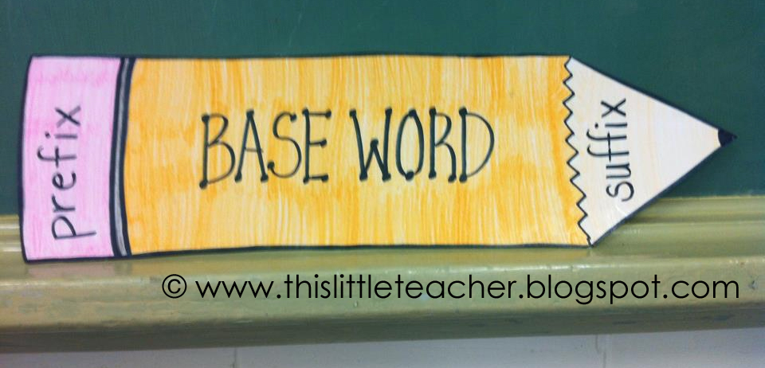
Name: __________________________
Block: __________________________
Date: ___________________________

Prefixes & Suffixes
I can identify prefixes, suffixes, and base words.
I can use my knowledge of prefixes, suffixes, and base words to define an unknown word.

Directions: As you watch the Flocabulary video, fill in the blanks within the lyrics!

[Prefixes: Like a Remix!]

Prefixes!
It's like a remix.
It changes things,
Like what a word means.
You can find 'em at the front of a word.
Learn 'em, you need 'em,
To figure out words and their meanings. (x2)
________ are an important part,
They tell you about a word, right from the start.
When you see ________, that means not,
Like unintelligent or the word nonstop.
It's a few more for not, that I'll hit you with,
________, if you can't read, then you're illiterate.
Inactive? No. Not moving,
Impossible is something you cannot be doing.
Irrational - you should have thought a bit,
________ mean opposite.
If you disagree, well hey, that's cool,
But your whole style gets devalued.
The prefix ________ means against,
You're antisocial if you don't have friends.
Here comes the intermission, everybody sing,
'Cause ________ means between and the hook's here, see?
Like...
Prefixes!
It's like a remix.
It changes things,
Like what a word means.
You can find 'em at the front of a word.
Learn 'em, you need 'em,
To figure out words and their meanings. (x2)
Allow me to reintroduce this word,
'Cause ________ means again, let's be sure you heard.
Even the word prefix has a prefix in it,
________ means before, man, I hope y'all remembering.
You may ask where they come from,
Most are ________, there's a whole bunch of 'em,
Like ________ is small,
________ is one. Are you hearin me, y'all?
I could talk in a monotone on a telephone,
And ________ goes the distance just like a telescope.
If you kinda understand that's ________,
You'll halfway get it till you commit it to memory.
Keep these in your mind's foreground,
'Cause ________ means front and you'll need 'em around.
This song is over and I don't mean ending,
It's overqualified, too much of a good thing.
Prefixes!
It's like a remix.
It changes things,
Like what a word means.
You can find 'em at the front of a word.
Learn 'em, you need 'em,
To figure out words and their meanings. (x2)

[Base Words]
- A ________________ is a complete word that can stand alone. It does not need help from a _______________ or a ________________ for meaning.
- Example: _______________________
Team Practice: Underline the base word!
Played | Running | Quickly | Reheat

[Prefixes]
- A ________________ is a word part added to the _____________________ of the root word or base word.
- They change the ______________________ of the base word.
Team Practice: Underline the base word & circle the prefix!
Redo | Unhappy

Directions: As you watch the Flocabulary video, fill in the blanks within the lyrics!

[Suffixes: At the End of a Word]

Listen up, I don't know if you heard,
But if you have a need for the meaning of a word,
Just take a look and check at the end;
If a ________ is there then that'll be your friend.
Like ________, it's able to be done,
If it's visible it's able to be seen like the sun.
I'm capable of having fun but now I gotta run to
'-A-L', ________ is another one.
That means it relates to the root word,
Like natural is all about nature; observe
How the suffix, ________ means made of whatever,
Wooden is made out of wood, now that's clever.
I dig golden nuggets like a miner, cause
________ means one who does.
A baker, no doubt, that's the one who bakes,
What about the suffix ________? Let's get it straight.
Of course it means full of, I hope that's helpful,
I mean full of help with this lesson we dealt you.
What about ________ O-U-S'?
That also means full of; there's no need to guess.
Like someone who's gracious is full of grace,
If you're feeling nervous, you might wanna meditate.
If it ends with ________ that means it tends to be,
You tend to feel good when you're cheery, so cheer for me.
Suffixes, these are the suffixes
At the end of a word, they tell you what it is.
If you need the meaning of a word, you can trust:
If you look at the end, you can tell by the suffix.
Yeah, you see all you've got to do is look at the end. Now hold up, here are some more,
right:
There's verse two cause there's still a few suffixes left,
Like ________, now they represent
The act, result or state of something done,
Like if it's cancelled you get a cancellation.
If it's contagious then it's a contagion,
So you need to vacate go on a vacation.
Okay, I'm not trying to be exhaustive,
The ________ suffix means wait, I lost it.
Oh yeah, it means tending to,
Like abusive tends to create abuse.
Next is ________ and it means without,
Without care is careless, that's not what I'm about.
We stay peerless, fearless,
The flow is Van Gogh, but I will never be earless.
Can't keep running fast 'cause now I'm all spent,
Guess I should have taken another supplement.
The ________ suffix is the result or act of,
If it's in containment, it's the result of being packed up.
Make an amendment, keep adding, don't rest,
I'm never living in a state of carelessness.
________ means the state of; my restlessness
Is probably cause I'm studying for this suffix test.
Don't forget ________, that's the direction of,
Forward never backward, we gotta keep stepping up!
That ain't all the suffixes, either; that's just the most popular ones.
Suffixes, these are the suffixes
At the end of a word, they tell you what it is.
If you need the meaning of a word, you can trust:
If you look at the end, you can tell by the suffix.

[Suffixes]
- A ________________ if a word part added to the ________ of a root or base word.
- They change the _________________ of the base word.
Team Practice: Underline the base word & box the prefix!
Wonderful | Loudly

Team Practice: Read the following sentences. Define the underlined word.
- His sickness made him miss school last Tuesday.
Sickness means: ________________________________________________________________________
- Madison Bumgarner, the pitcher for the San Francisco Giants, led his team to a World Series win!
Pitcher means: __________________________________________________________________________

Name: __________________________
Block: __________________________
Date: ___________________________

Independent Practice: Prefixes
Directions: Using your knowledge of prefixes, define each of the following words.
Word: | Meaning:
1. disown
2. unprepared
3. prebake
4. misinform
5. excuse

Directions: Read the following sentences. Define the underlined word.
6. I worked too quickly on my quiz and made a mistake.
Mistake means: _______________________________________________________________________
7. It was unfair that the student took full credit for something he did not do.
Unfair means: _________________________________________________________________________
8. At the movie theatre, they always show previews before the actual movie.
Preview means: _________________________________________________________________________
9. Please read the excerpt from The Hunger Games.
Excerpt means: ________________________________________________________________________
10. She disliked that it rained during her soccer game.
Disliked means: ______________________________________________________________________
Above & Beyond: In the box below, list out as many words you can that have prefixes! Circle all of the prefixes!

Name: __________________________
Block: __________________________
Date: ___________________________

Homework: Prefixes
Directions: Using your knowledge of prefixes, define each of the following words.
Word: | Meaning:
1. disappointed
2. unprepared
3. pregame
4. misinform
5. example

Directions: Read the following sentences. Define the underlined word.
6. Ms. Luteman misprinted the homework and had to run the copies again.
Misprinted means: ______________________________________________________________________
7. It is unbelievable how well-behaved the fifth graders are!
Unbelievable means: ____________________________________________________________________
8. Before you begin baking the cookies, you must preheat the oven.
Preheat means: _________________________________________________________________________
9. The ancient artifacts were extracted from the ground.
Extracted means: _______________________________________________________________________
10. The sun disappeared behind the clouds.
Disappeared means: ____________________________________________________________________

Name: __________________________
Block: __________________________
Date: ___________________________

Independent Practice: Suffixes
Directions: Using your knowledge of suffixes, define each of the following words.
Word: | Meaning:
1. fearful
2. sadly
3. homeless
4. driver
5. kindness

Directions: Read the following sentences. Define the underlined word.
6. When your parents pick you up, the car tag needs to be visible.
Visible means: _______________________________________________________________________
7. All of the fifth grade students are very helpful.
Helpful means: _________________________________________________________________________
8. The doctor’s office will call you if they receive a cancellation.
Cancellation means: ___________________________________________________________
9. Make sure that you read all of the directions and take your time so you do not make careless mistakes.
Careless means: ________________________________________________________________________
10. I will gladly watch your classroom for you.
Gladly means: ______________________________________________________________________

Name: __________________________
Block: __________________________
Date: ___________________________

Homework: Suffixes

Directions: Using your knowledge of suffixes, define each of the following words.
Word: | Meaning:
1. baker
2. faster
3. joyful
4. slowly
5. sweetness

Directions: Read the following sentences. Define the underlined word.
6. My brother, Trevor, used to wish he was a professional race car driver.
Driver means: ___________________________________________________________________________
7. Colin Kaepernick is stronger than Eli Manning.
Stronger means: ________________________________________________________________________
8. It is dangerous to walk backward down the hallway because you might hit something.
Backward means: ______________________________________________________________
9. The teachers happily watched the students perform at the talent show.
Happily means: _________________________________________________________________________
10. The boys on the football team are fearless.
Fearless means: ______________________________________________________________________

