Name: ____________________________
Block: ____________________________
Date: _____________________________
Explanations
Let’s review how to paraphrase!

Directions: Read the supporting detail below for a prompt about why it is important to save the forests. Then annotate the picture, and passage. Lastly write a paraphrased piece of evidence on the lines below that supports the supporting detail.

Supporting Detail: First of all, we must save the forests in America in order to protect our native plants and animals.
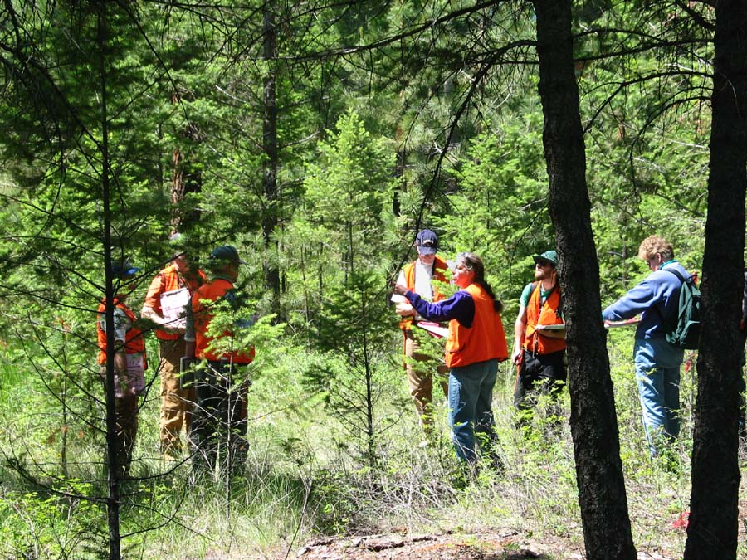
“Our forests, with their billions of trees, are unbelievably important for our society. Forests are perhaps our most valuable natural resource. They are home to the many types of animals and wildlife that would not survive if we cut them down. It is necessary to preserve, protect, and expand our forests for the needs of future generations.”

Evidence:
____________________________________________________________________________________________________________________________________________________________________________________________________________________________________________________________________________________________________________________________________________________________________________________________________________________________________________________________________________________________________

Explanations
- An explanation tells your reader how the ___________________connects to the ___________ ___________________ of the paragraph.
- An explanation sentence should answer two questions:
  - What does the evidence _______________?
  - Why does it ___________?

- Before your write an explanation:
  - Re-read your _________________________________.
  - Re-read your _________________.
- Writing an Explanation
  - Step 1: Use a transition word for ____________________.
    - _______________________
    - _______________________
    - _______________________
    - _______________________
  - Step 2: Explain what your evidence means and how it supports the topic sentence in your _____________ ___________________.
Exemplary Explanations
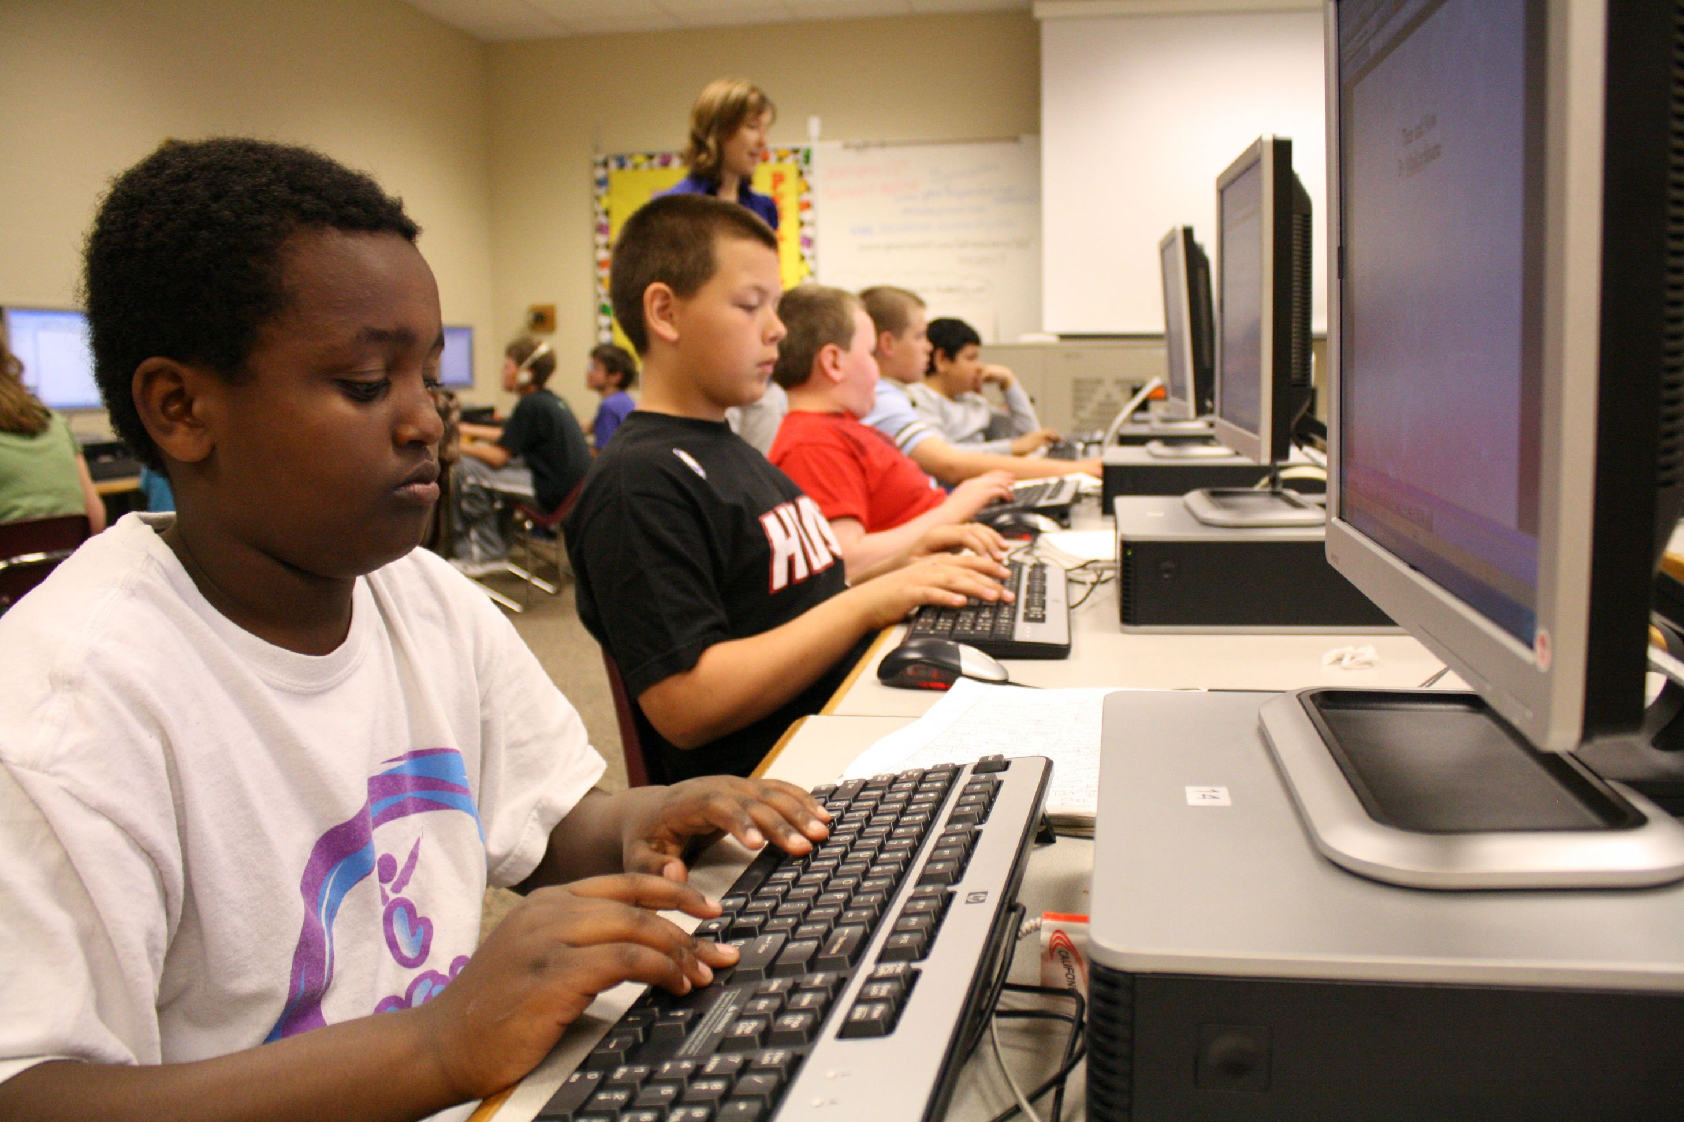
There is no question that computer skills are necessary to have today. First of all, without computer skills, it will be hard to get a college degree. In fact, Professor John Kressler from Vanderbilt University says that a majority of homework must be completed on the computer.

Explanation: In other words, computer skills are necessary because you cannot get a college degree without doing your assignments.
Partner Talk
How does the explanation connect the evidence to the topic sentence?
________________________________________________________________________________________________________________________________________________________________________________________________________________________________________________________________________________________________________________________________________________________________________

TEAM Practice
Evidence: In addition, finding a good job will be difficult if you aren’t good with computers. For instance, according to the same article, “many companies won’t hire someone who has no computer skills”

Explanation: ________________________________________________________________________________________________________________________________________________________________________________________________________________________________________________________________________________________________________________________________________________________________________
TEAM Practice: Writing Explanations
Topic Sentence: Global warming is the biggest problem in the world today.

Supporting Detail #1: First of all, global warming is a huge problem because it causes “super” storms

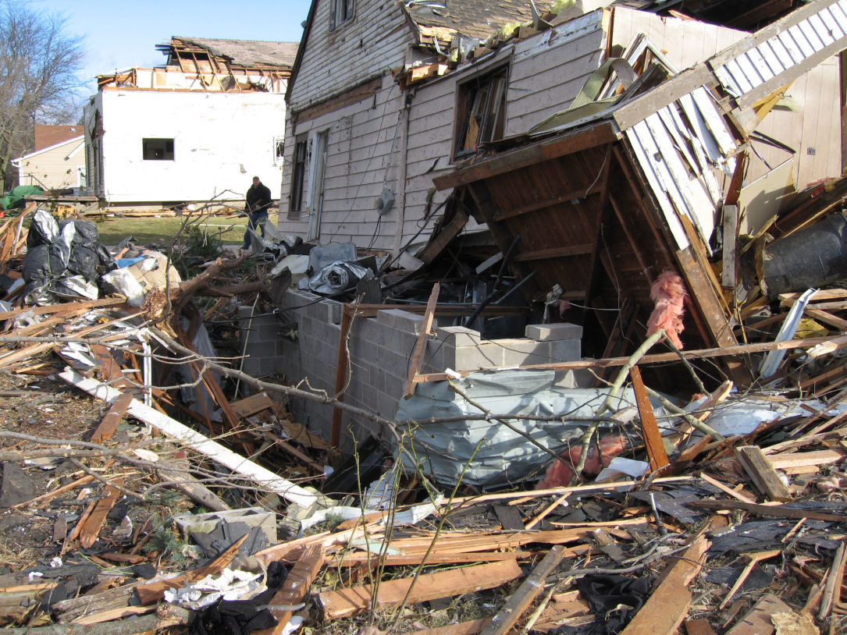
Evidence #1: For example, according to the article “Impacts of Climate Change” published in the United Nations Magazine, numerous terrible weather events cost billions of dollars in damage in 2011.

Explanation #1:
____________________________________________________________________________________________________________________________________________________________________________________
__________________________________________________________________________________________
Partner Talk
How does the explanation connect the evidence to the topic sentence?
______________________________________________________________________________________________________________________________________________________________________________________________________________________________________________________________________________

Teammate Practice: Writing Explanations

Topic Sentence: There are many reasons that it is important to save forests.

Supporting Detail: Additionally, we must save the forests now so they are not destroyed forever.

Supporting Evidence: In fact, the same article says that once forests disappear, they will never grow back and we will lose all their resources.
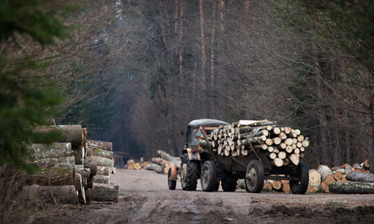
Write an explanation: ______________________________________________________________________________________________________________________________________________________________________________________________________________________________________________________________________________

Above and Beyond
How does the explanation connect the evidence to the topic sentence? ______________________________________________________________________________________________________________________________________________________________________________________________________________________________________________________________________________

Solo Practice

Directions: Read the prompt below. Then read the beginning of an expository paragraph that Sally 5th Grader has started writing. Help her keep going by writing an explanation on the lines below.

Prompt: Write a expository paragraph about if it is possible to change how smart you are.

Topic Sentence: Some people do not know this, but you can actually change how smart you are.

Supporting Detail #1: First of all, one way you can change how smart you are is by challenging your brain.

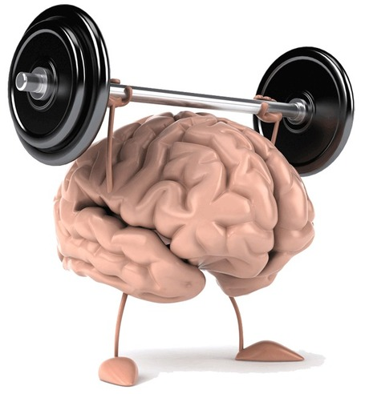
Evidence #1: For instance, an article from Health and Science says, the more your mind is challenged to learn, the more your brain cells grow.
Write an explanation: ______________________________________________________________________________________________________________________________________________________________________________________________________________________________________________________________________________

