5th grade Literacy Booklist
This year, we will be reading the following books in 5th grade!
We would like all 5th graders to have their own personal copy of each of these books!

Quarter 1: Wonder By: R.J. Palacio

August (Auggie) Pullman was born with a facial deformity that prevented him from going to a mainstream school―until now. He’s about to enter fifth grade at Beecher Prep, and if you’ve ever been the new kid, then you know how hard that can be. The thing is Auggie’s just an ordinary kid, with an extraordinary face. But can he convince his new classmates that he’s just like them, despite appearances?

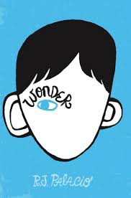
R. J. Palacio has crafted an uplifting novel full of wonderfully realistic family interactions, lively school scenes, and writing that shines with spare emotional power.

Quarter 2: The Westing Game By: Ellen Raskin

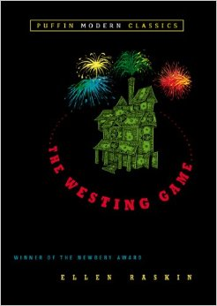
A bizarre chain of events begins when sixteen unlikely people gather for the reading of Samuel W. Westing’s will. And though no one knows why the eccentric, game-loving millionaire has chosen a virtual stranger—and a possible murderer—to inherit his vast fortune, on things for sure: Sam Westing may be dead…but that won’t stop him from playing one last game!
Winner of the Newbery Medal
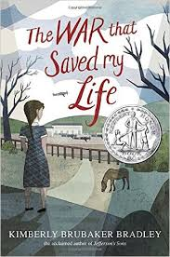
Quarter 3: The War That Saved My Life By: Kimberly Brubaker Bradley

Nine-year-old Ada has never left her one-room apartment. Her mother is too humiliated by Ada’s twisted foot to let her outside. So when her little brother Jamie is shipped out of London to escape the war, Ada doesn’t waste a minute—she sneaks out to join him.
So begins a new adventure of Ada, and for Susan Smith, the woman who is forced to take the two kids in. As Ada teaches herself to ride a pony, learns to read, and watches for German spies, she begins to trust Susan—and Susan begins to love Ada and Jamie. But in the end, will their bond be enough to hold them together through wartime? Or will Ada and her brother fall back into the cruel hands of their mother?

2016 Newberry Honor Book

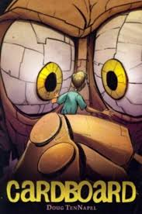
Quarter 4: Cardboard By: Doug TenNapel

When cardboard creatures come magically to life, a boy must save his town from disaster.
Cam's down-and-out father gives him a cardboard box for his birthday and he knows it's the worst present ever. So to make the best of a bad situation, they bend the cardboard into a man-and to their astonishment, it comes magically to life. But the neighborhood bully, Marcus, warps the powerful cardboard into his own evil creations that threaten to destroy them all!

